# Exam questions

**What constitutes a good cognitive neuroscience experiment?**

* Corrected for family-wise error (dead salmon – false positives)
* Number of participants
  + Average away random effects away
  + Evens out the result
* Quality of the stimulus (background, smiles)
* A functional localisation of the area in interest (for FFA)
* Avoid reverse inference (at least the bad kind)
  + The issue of building on other’s theories (without testing them ourselves)
  + Concluding that recognition of famous faces relies on retrieval from LTM because the areas found active have been associated with memory.

[**Extra from vox** ( https://www.vox.com/2016/7/14/12016710/science-challeges-research-funding-peer-review-process](https://www.vox.com/2016/7/14/12016710/science-challeges-research-funding-peer-review-process) )

* *Too many studies are poorly designed. Blame bad incentives.*
  + Not publish all their studies
  + P-hacking for positive results
  + Don’t include effect-size
* *Replicating results is crucial. But scientists rarely do it.*
  + Journals are also reluctant to publish replication studies unless "they contradict earlier findings or conclusions," Allem writes.The result is to discourage scientists from checking each other's work. "Novel information trumps stronger evidence, which sets the parameters for working scientists."
* *Scanner drift*
  + Has the data been high-pass filtered?
  + Removing linear drifts from a timecourse is the simplest possible high-pass filter.
* *Correction for multiple comparisons*
  + In fMRI we do A LOT of tests all over the brain (literally 100,000). The false discovery rate is very high using p<0.05 (yielding 5,000 voxels active by chance on average), unless we correct for multiple comparisons. Are the reported statistics corrected for multiple comparisons?
* *Consistency*
  + The validity of a reported statistic relies on the procedure being determined before the analysis is conducted. Data massage can often be recognized by strange ad hoc procedures where one test is conducted on one way, and another in a very different way. So, does the experiment adopt a consistent approach to its statistical (alpha level) threshold?
  + Are the result represented in a consistent manner, e.g. is the main “story” also the strongest result? Is it one of many? Do results look as though they were delivered with a shot-gun?
* *Clarity*
  + Are the methods described in a manner which makes it possible for others to replicate the experiment?
* **Clear Hypothesis -> Only comment on results**
  + **The rest is exploratory analysis**
* **Statistical power (More participants, more data)**
* **Familywise error & False discovery rate**
  + **Basically it is because controlling the FWER controls the probability of making a Type I error AT ALL and the FDR allows Type I Errors but controls how many of them you make in proportion to your true positives. The FDR has a higher power because it has a higher Type I error rate, which is a classical trade-off.**
* **Better temporal resolution in MEG**
* **Meaningful contrasts**
* **Baseline**
* **Replicability**
* **Experimental design**

**Could your experiment have been done with EEG and what would have been the outcome?**

* Yes, but with different findings.
  + When does the perception of a face happen?
  + When does the recognition of a face happen?
  + Does the familiarity of a face affect when the recognition occurs?
* FFA - Electrophysiological response to faces: the N170 response (Gazzaniga p. 253)
* Zheng, Mondloch, and Segalowitz recorded [event-related potentials](https://en.wikipedia.org/wiki/Event-related_potentials) in the brain to determine the timing of recognition of faces in the brain.[[56]](https://en.wikipedia.org/wiki/Face_perception#cite_note-Zheng_2012_1451%E2%80%931461-56) The results of the study showed that familiar faces are indicated and recognized by a stronger N250,[[56]](https://en.wikipedia.org/wiki/Face_perception#cite_note-Zheng_2012_1451%E2%80%931461-56) a specific wavelength response that plays a role in the visual memory of faces.[[57]](https://en.wikipedia.org/wiki/Face_perception#cite_note-57) Similarly, Moulson et al.[[58]](https://en.wikipedia.org/wiki/Face_perception#cite_note-58) found that all faces elicit the [N170](https://en.wikipedia.org/wiki/N170) response in the brain.
* **Schweinberger and colleagues (2002)** conducted an ERP repetition priming study of famous faces and famous names (in two separate studies) and reported a similar pattern of activity for both stimuli at a late post-recognition time frame (500–600 ms). They suggested that the findings were consistent with the notion of separate stimulus specific perceptual analyses, but that famous faces and names shared a common source for retrieval of semantic information. A similar conclusion was reached in an ERP study examining age-related changes to face and name recognition (Pfutze, Sommer, & Schweinberger, 2002).
* 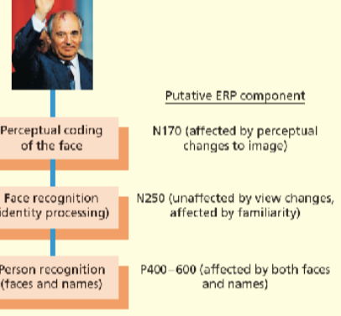
* Pictures of animal faces were associated with a N170 of similar amplitude compared to pictures of human faces, but with delayed peak latency.
* Multiple repetitions of learned faces also elicited increased central-parietal positivity between 400 and 600 msec and caused a bilateral increase of inferior-temporal negativity (>300 msec) compared with novel faces.
* The main finding was that the subject's own face produced a focal negative deflection (N250) in posterior channels relative to nontarget faces. The task-relevant Joe target face was not differentiated from other nontarget faces in the first half of the experiment. However, in the second half, the Joe face produced an N250 response that was similar in magnitude to the own face. These findings suggest that the N250 indexes two types of face memories: a preexperimentally familiar face representation (i.e., the "own face" and a newly acquired face representation (i.e., the Joe/Jane face) that was formed during the course of the experiment.

**What are the strengths and weaknesses of fMRI as a method?**

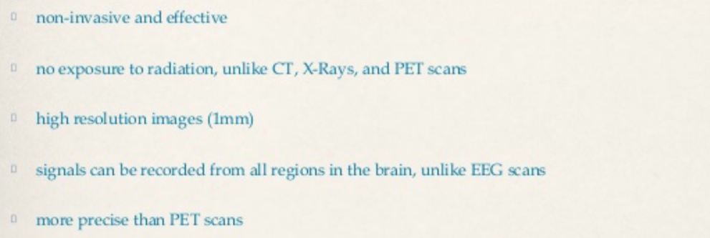

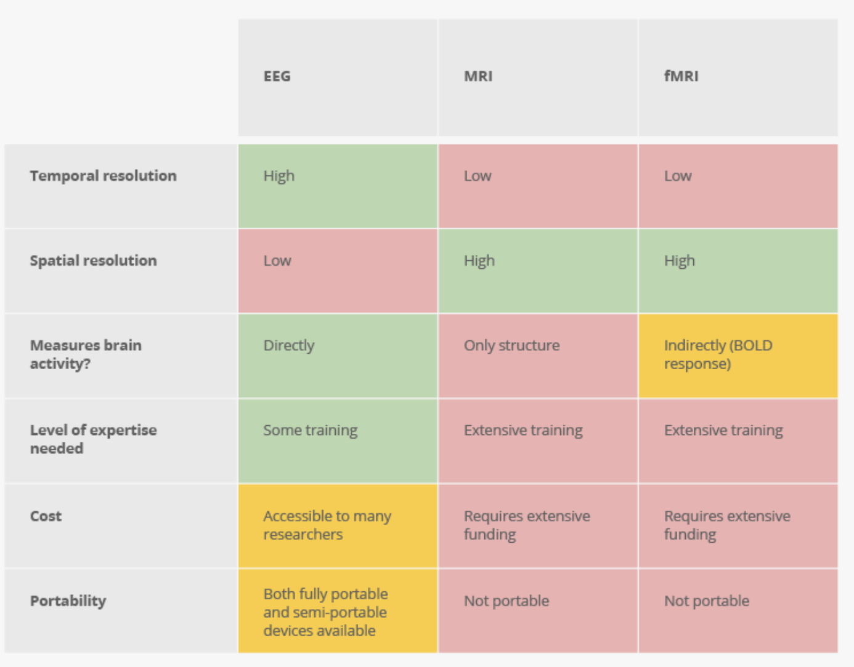

**Compared to EEG**

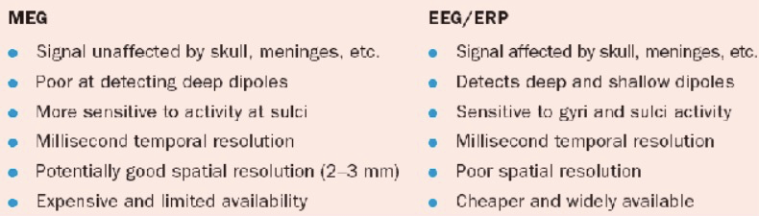

The number, location and magnitude of electrical sources are unknown, therefore there is an infinite number of ways the measured signal could have arisen.

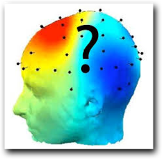

• This is known as the “inverse problem”.

* More than one set of dipoles that can explain a certain voltage distribution
* Right now: not possible to provide a p-value or likelihood ratio for a statement about the anatomical location of an ERP effect.
* Spatial resolution is simply not one of the strengths of the ERP technique

-scalp =Blurrying

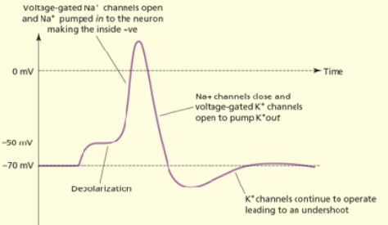

**fMRI isn’t great at establishing the order of brain activity**

Brain regions "turn on" within milliseconds of one another. But "the hemodynamic response, just due to the blood vessels, is about two seconds.

Spatially superior, but… crude view of things. There [**can be hundreds**](https://cfn.upenn.edu/aguirre/wiki/public:neurons_in_a_voxel) of thousands of neurons in a tiny voxel.

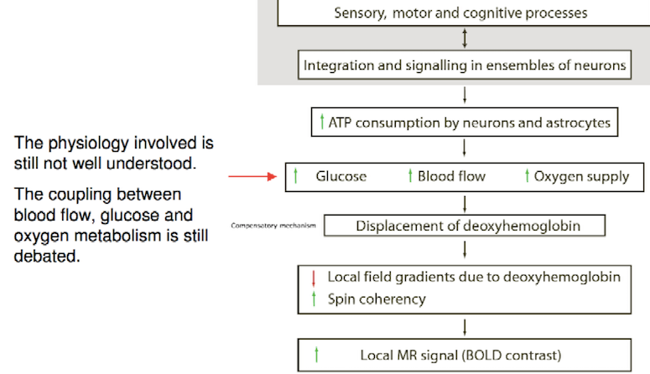

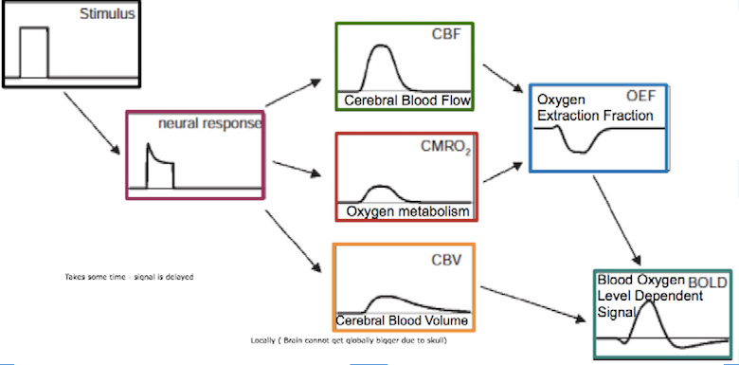

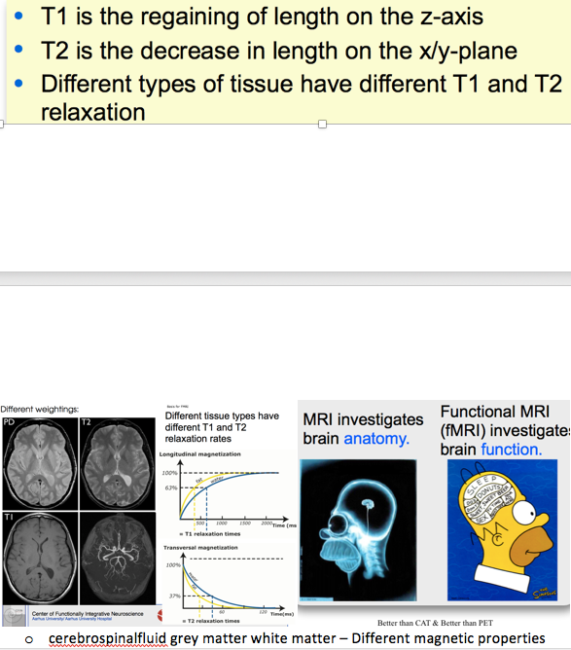 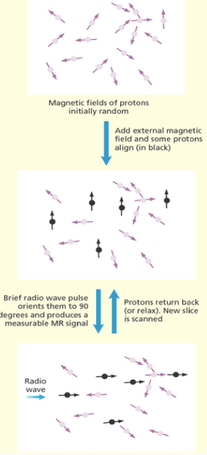

water spins - fat does too

wobble back and send radiwaves back - add op to give strong signal (desynchronize = can’t add up)

**Explain the principles of cognitive subtraction**

Def: Activity in a control task is subtracted from activity in an experimental task.

Both event-related and block design.

* **Example:** A task involves both visual perception and low-level processing. Another task involves only low-level processing. Subtracting the data = only visual perception is left
* **Example:** To work out which regions are involved in spoken words; the researchers compared the viewing of written words with reading a word aloud. In this task, both experimental and baseline involved visual processing of the word, and word recognition, and therefore subtracting should cancel out things
* **Problems:**
  + Not so correct (pure insertion). But we have no other methods
    - **Pure insertion** = the assumptions that adding an extra component does not affect the operation of earlier ones in the sequence. (Loops and parallel processing)
    - There might be an interaction effect. The added component changes the effect of another component.
  + The subtraction method fMRI misses a lot of brain information that is important to the cognitive processes. Subtraction fMRI only shows the differences between the task activation and the control activation, but many of the brain areas activated in the control are obviously important for the task as well.

**Assumptions:**

* fMRI =
  + changes in blood flow is related to brain activity. When an area of the brain is in use, blood flow to that region also increases.
  + Cognitive subtraction - **Pure assertion**
  + **Localisation of function** - many cognitive functions can be localized to specific brain regions (not holistically)
    - “Some philosophers entirely reject any notion of localization of function and thus believe fMRI studies to be profoundly misguided.[15] These philosophers maintain that brain processing acts holistically, that large sections of the brain are involved in processing most cognitive tasks (see holism in neurology and the modularity section below). One way to understand their objection to the idea of localization of function is the radio repair man thought experiment.[16] In this thought experiment, a radio repair man opens up a radio and rips out a tube. The radio begins whistling loudly and the radio repair man declares that he must have ripped out the anti-whistling tube. There is not really any anti-whistling tube in the radio and it is obvious that the radio repair man has confounded function with effect”
  + **Reverse inference -** The issue of building on other’s theories (without testing them ourselves)
    - would be the question of what cognitive process/behavior etc. is occurring given the brain activity. Basically, reasoning backwards from brain activity.
    - “A spectacular recent example of the misuse of reverse inference is that of [James Fallon](http://www.smithsonianmag.com/science-nature/the-neuroscientist-who-discovered-he-was-a-psychopath-180947814/), who used a brain scan to diagnose himself as a [psychopath](https://knowingneurons.com/2013/11/22/the-psychopathic-brain-broken-and-free-of-blame/).  Fallon noticed that a scan of his own brain, taken during a study on dementia, had abnormally low activity in some frontal lobe areas.  Other research has implicated these areas in empathy and moral reasoning, which are allegedly abnormal in psychopathic individuals, leading Fallon to conclude that he too was a psychopath.  Nonetheless, research on dementia does not typically use empathy tasks, so it is unlikely that the reduced activity in Fallon’s frontal lobes reflected pathological empathic ability.  Fallon made a reverse inference – and a silly one at that.”
    - CORRELATION DOES NOT IMPLY CAUSATION
      * [**"Dogs understand both words and intonation of human speech."**](https://www.theguardian.com/science/2016/aug/30/dogs-understand-both-words-and-intonation-of-human-speech) The story was based off a *Science* [**paper**](http://science.sciencemag.org/content/353/6303/1030) that found words of praise raised activation in the left hemisphere of dogs’ brains while being scanned in an fMRI. That result was interpreted in many articles to mean the dogs understood the words, because in humans, we respond to words we understand with a similar pattern of activation.
    - We work in models, and they are only “best guesses”
* Behavioural data (models build on assumptions)

**Why do we need behavioural data?**

* RT = the time course of the experiment
* Button presses – ensure the attention and focus of the participant
  + If not, they might be planning their weekend instead of attending
* RT can back up theories/hypotheses
* ***Mental chronometry*** is studied using measurements of reaction time (RT), which is the elapsed time between the presentation of a sensory stimulus and the subsequent behavioral response. In psychometric psychology it is considered to be an index of processing speed.[[1]](https://en.wikipedia.org/wiki/Mental_chronometry#cite_note-Jensen-1) That is, it indicates how fast the individual can execute the mental operations needed by the task at hand. In turn, speed of processing is considered an index of processing efficiency. The behavioral response is typically a button press but can also be an eye movement, a vocal response, or some other observable behavior. RT is constrained not only by the speed of signal transmission in white matter, but also by the properties of synaptic and neural processing in cortical gray matter.[[2]](https://en.wikipedia.org/wiki/Mental_chronometry#cite_note-2) Its utility as a dependent variable for drawing conclusions about information processing is constrained by the experimental design, measurement technology, and mathematical theorizing of the enterprise.